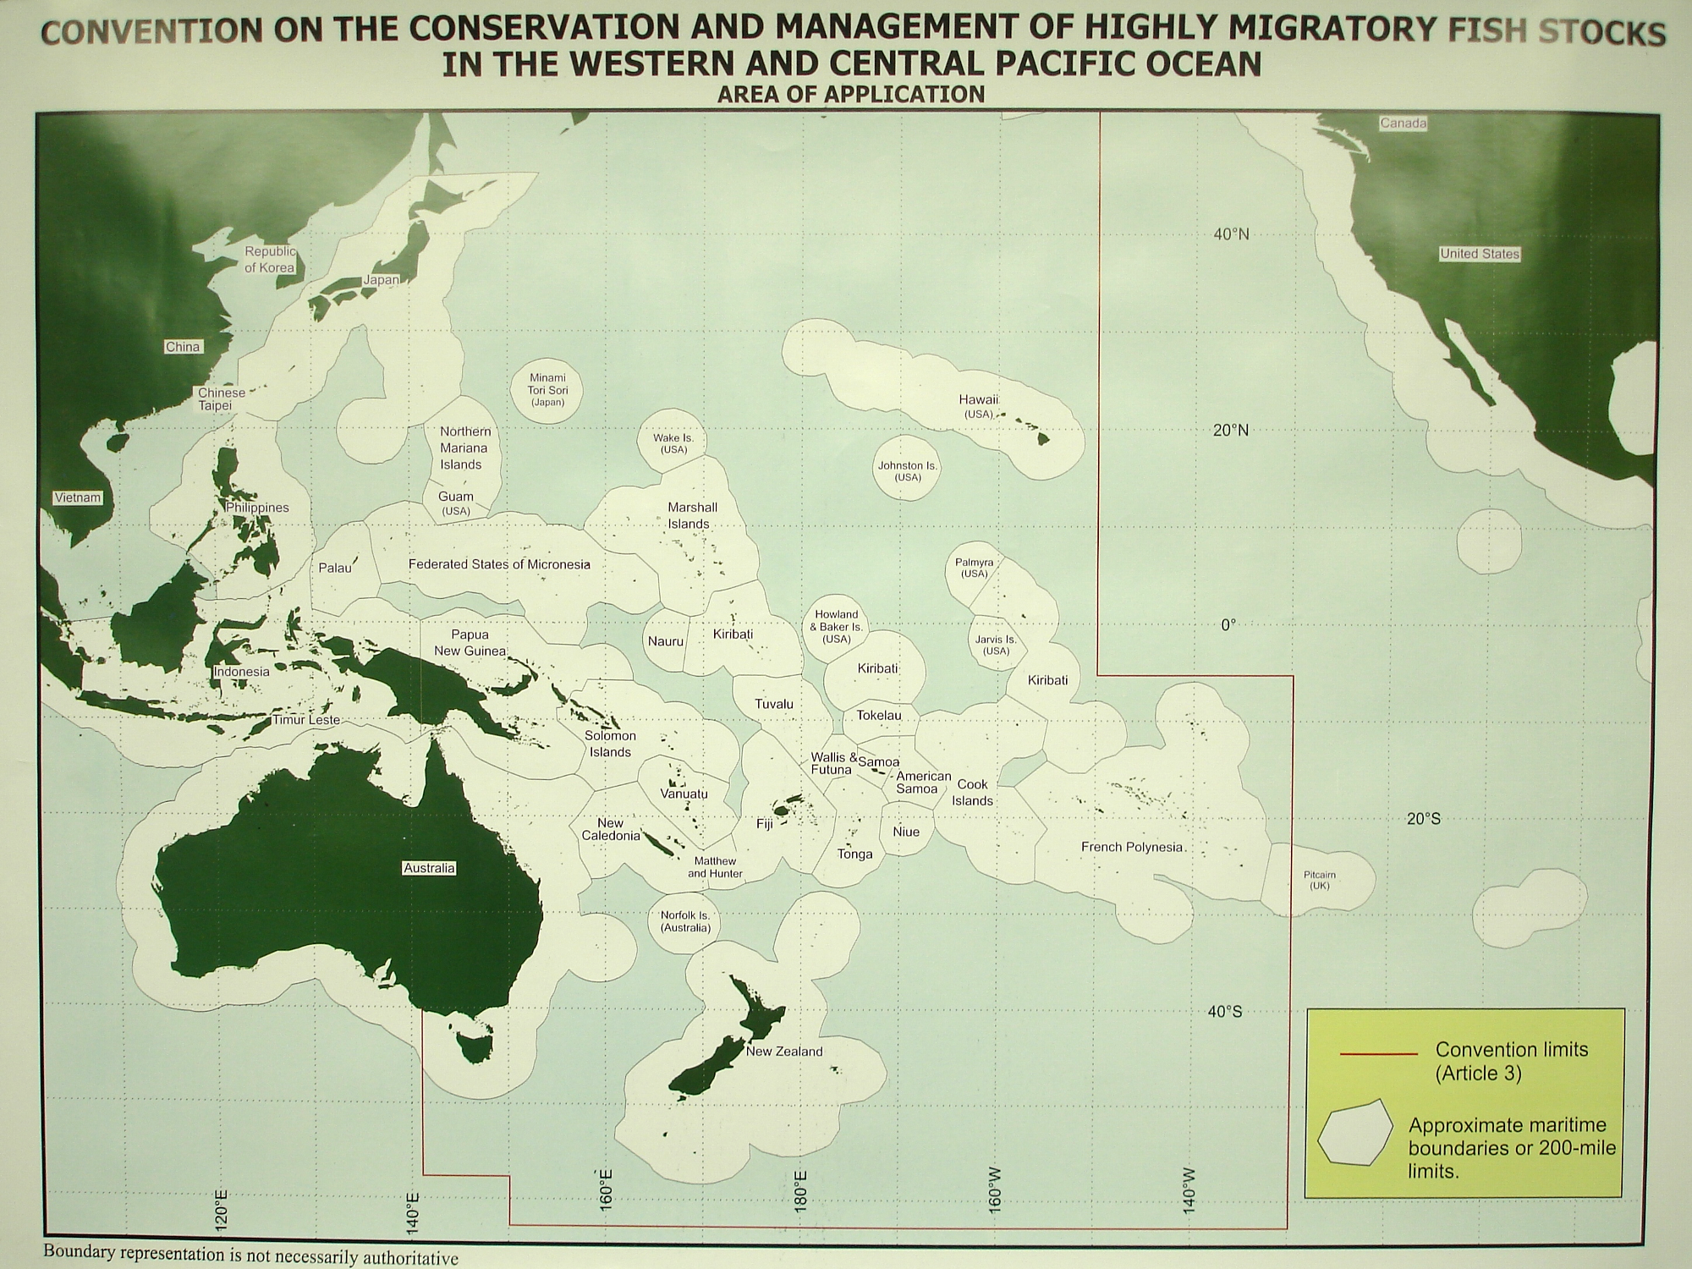
備註NOTE：
- This figure produced by WCPFC is solely for the purpose of illustrating the scope of the high seas within the Convention Area and does not imply the endorsement by the Commission of any member’s claims to past, present or future maritime territories.
本圖係中西太平洋漁業委員會(WCPFC)製作，僅供展示其公約範圍及所包含之袋狀公海海域，不代表該委員會支持各會員對於任何過去、現在或未來海域之主張。
- As a member of WCPFC, CGA has placed the figure produced by WCPFC on its website to serve as the basis for our enforcement of patrols in the high seas.
我國為WCPFC之會員國，本署因執行WCPFC公海海域巡護任務，爰於本署網站放置該委員會所製之海域範圍圖，以為本署執行前揭任務之依據。

Attachment 1

